 | 26.9.12 Editors - Properties Editor - Modifiers Properties Tab - Grease Pencil - Deform Modifiers
Table of content
Detailed table of content 1
Deform modifiers 4
Armature 4
Hook 6
Lattice 8
Noise 9
Offset 12
Smooth 13
Thickness 15

Detailed table of content

Detailed table of content
Detailed table of content 1
Deform modifiers 4
Armature 4
Object 4
Vertex Group 4
Invert 5
Bind to 5
Vertex Groups 5
Bone Envelopes 5
Hook 6
Object 6
Vertex Group 6
Invert 6
Strength 6
Reset 6
Recenter 6
Select 6
Assign 6
Falloff 7
Type 7
Radius 7
Uniform Falloff 7
Influence 7
Layer 7
Invert 7
Pass 7
Invert 7
Material 7
Invert 7
Pass 7
Invert 7
Lattice 8
Object 8
Vertex Group 8
Invert 8
Strength 8
Influence 8
Layer 8
Invert 8
Pass 8
Invert 8
Material 8
Invert 9
Pass 9
Invert 9
Noise 9
Position 9
Strength 9
Thickness 9
UV 9
Noise Scale 9
Noise Offset 9
Noise Seed 9
Randomize 9
Step 9
Influence 10
Layer 10
Invert 10
Pass 10
Invert 10
Material 10
Invert 10
Pass 10
Invert 10
Vertex Group 10
Invert 10
Custom Curve 10
Navigation elements 10
Zoom in and out 11
Tools 11
Reset View 11
Vector Handle 11
Auto Handle 11
Auto Clamped Handle 11
Extend Horizontal 11
Extend Vertical 11
Reset Curve 11
Use Clipping 11
Delete Points 11
Curve window 11
X / Y 12
Offset 12
Location X, Y, Z 12
Rotation X, Y, Z 12
Scale X, Y, Z 12
Randomize 12
Offset 12
Rotation 12
Scale 12
Influence 12
Layer 12
Invert 12
Pass 12
Invert 12
Material 13
Invert 13
Pass 13
Invert 13
Vertex Group 13
Invert 13
Smooth 13
Mode 13
Position 13
Strength 13
Thickness 13
UV 13
Factor 13
Repeat 14
Influence 14
Layer 14
Invert 14
Pass 14
Invert 14
Material 14
Invert 14
Pass 14
Invert 14
Vertex Group 14
Invert 14
Custom Curve 14
Navigation elements 15
Zoom in and out 15
Thickness 15
Uniform Thickness 15
Thickness Factor 15
Weighted 15
Influence 15
Layer 15
Invert 15
Pass 15
Invert 15
Material 15
Invert 15
Pass 16
Invert 16
Vertex Group 16
Invert 16
Custom Curve 16
Navigation elements 16
Zoom in and out 16
Tools 16
Reset View 16
Vector Handle 16
Auto Handle 16
Auto Clamped Handle 16
Extend Horizontal 16
Extend Vertical 17
Reset Curve 17
Use Clipping 17
Delete Points 17
Curve window 17
X / Y 17

Deform modifiers
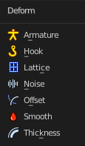

Armature
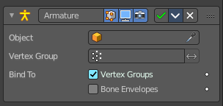
An armature system allows to deform objects accurately by posing bones. The Armature modifier contains the armature settings at the mesh end.
This modifier gets created automatically when you parent a grease pencil to an armature.

Object
The name of the armature object used by this modifier.

Vertex Group
A vertex group of the object, which weights will be used to determine the influence of this modifier’s results when mixing it with the results from other Armature ones.
This is only of use when having at least two of these modifiers on the same object, with Multi Modifier activated.

Invert
Inverts the influence set by the vertex group.

Bind to

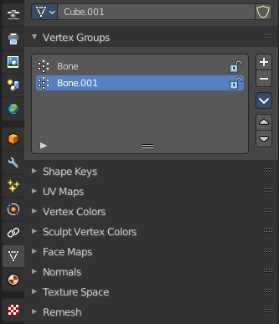
Vertex Groups
Meshes and lattices only. Use Vertex groups for deforming the mesh. A bone named “forearm”, will only affect the vertices in the “forearm” vertex group. The influence of one bone on a given vertex is controlled by the weight of this vertex in the relevant group.
The vertex groups are located in the Object Data Properties in the Properties editor.

Bone Envelopes
Use the Bone envelopes to deform vertices or control points near them, defined by each bone’s envelope radius and distance.
When envelopes are disabled, Blender uses the set of existing vertex group names to determine which bones influences what mesh part.
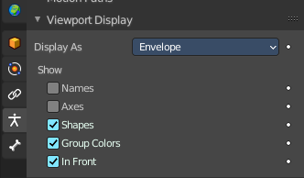
Bone envelopes display can be turned on in the Viewport Display panel in the Object Data properties tab in the Properties Editor. Display as ...

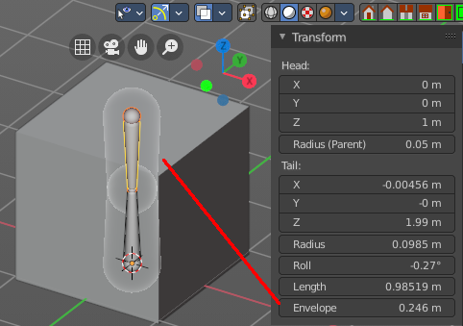
And can be adjusted in the Transform panel in the sidebar of the 3D View, in Edit mode.

Hook
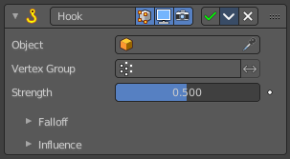
The Hook modifier is used to deform a mesh, curve or lattice by another object. When you move this hook object, then it pulls vertices or control points with it.
Assigning the hook object to specific vertices of the target object is done in Edit mode. The modifier shows a set of buttons then.
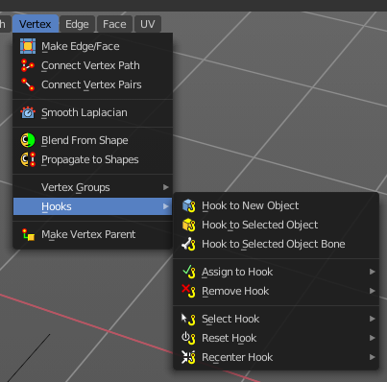
This modifier is automatically created when you add a Hook from the Hooks menu in the Edge menu in edit mode.
Some settings just exists in Edit mode.
Warning! The Hook Modifier stores vertex indices from the original mesh to determine what to affect. Modifiers that generate geometry, like Subdivision Surface, should always be put after the Hook modifier in the stack. Otherwise, the generated geometry can‘ t be affected by the hook’s influence.

Object
The name of the object to hook vertices to.

Vertex Group
Allows you to define the influence per vertex.

Invert
Inverts the influence of the selected vertex group.

Strength
Adjust this hooks influence on the vertices.

Reset
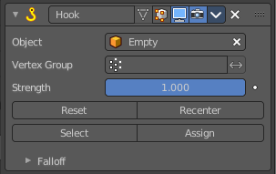
In Edit mode. Recalculate and clear the offset transform of the hook.

Recenter
In Edit mode. Set the hook center to the 3D cursor position.

Select
In Edit mode. Select the vertices affected by this hook.

Assign
In Edit mode. Assigns selected vertices to this hook.

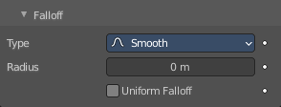
Falloff

Type
This can be used to adjust the kind of influence curve that the hook has on the mesh. You can also define a custom curve to get a much higher level of control.

Radius
The size of the hooks influence.

Uniform Falloff
Compensate non uniform scale, and use a uniform falloff.

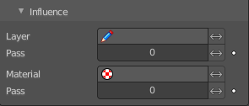
Influence

Layer
Restricts the effect only to one layer or to any layers that share the same pass index. Click to pick the layer that you want to use.

Invert
Inverts the influence.

Pass
The layer pass index.

Invert
Inverts the influence.

Material
Restricts the effect only to material that share the same material or pass index. Click to pick the material that you want to use.

Invert
Inverts the influence.

Pass
The material pass index.

Invert
Inverts the influence.

Lattice
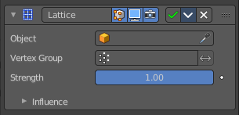
The Lattice modifier deforms the base object by the shape of a Lattice object. It can be used at meshes, curves, surfaces, text, lattices and even particles.
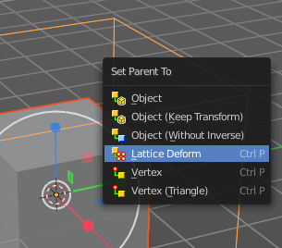
A Lattice modifier with valid settings can be added by selecting the object, holding down shift, select the target lattice object, and then choose Lattice Deform in the Parent menu.
Note! When you want to use a lattice to deform particles, then you need to place the Lattice modifier after the Particle System modifier.

Object
The Lattice object that deforms the base object.

Vertex Group
Limit the modifier’s effect to a vertex group of the base mesh.

Invert
Inverts the influence of the selected vertex group.

Strength
A factor to control blending between original and deformed vertex positions.

Influence

Layer
Restricts the effect only to one layer or to any layers that share the same pass index. Click to pick the layer that you want to use.

Invert
Inverts the influence.

Pass
The layer pass index.

Invert
Inverts the influence.

Material
Restricts the effect only to material that share the same material or pass index. Click to pick the material that you want to use.

Invert
Inverts the influence.

Pass
The material pass index.

Invert
Inverts the influence.

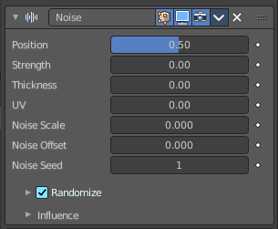
Noise
The Noise Modifier adds noise to make the grease pencil line unstable and noisy.

Position
Strength of the noise effect over the point location.

Strength
Strength of the noise effect over the point strength (opacity).

Thickness
Strength of the noise effect over the point thickness.

UV
Strength of the noise effect over the point UV rotation.

Noise Scale
Control the noise frequency scale.

Noise Offset
Offset the noise along the stroke.

Noise Seed
Add a random seed.

Randomize
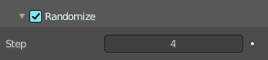
Use a random value over time.

Step
Number of frames before using a new random value.

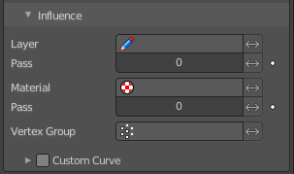
Influence

Layer
Restricts the effect only to one layer or to any layers that share the same pass index. Click to pick the layer that you want to use.

Invert
Inverts the influence.

Pass
The layer pass index.

Invert
Inverts the influence.

Material
Restricts the effect only to material that share the same material or pass index. Click to pick the material that you want to use.

Invert
Inverts the influence.

Pass
The material pass index.

Invert
Inverts the influence.

Vertex Group
Limit the influence to a vertex group.

Invert
Inverts the influence.

Custom Curve
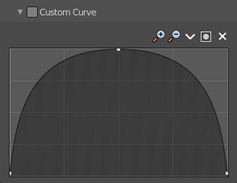
Use a custom curve to define the noise along the strokes.

Navigation elements
The navigation elements at the top are described from left to right.

Zoom in and out
The two buttons with the magnifying glass at it zooms in and out in the curve window.

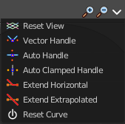
Tools
Tools is a menu where you can find some curve related tools.

Reset View
Resets the curve windows zoom.

Vector Handle
Set handle type to Vector.

Auto Handle
Set handle type to Auto.

Auto Clamped Handle
Set handle type to Auto Clamped.

Extend Horizontal
Extend the curve points horizontal before the first curve point and after the last curve point.

Extend Vertical
Extend the curve points vertical before the first curve point and after the last curve point.

Reset Curve
Resets the curve to the initial shape.

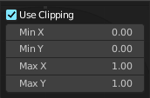
Use Clipping
Clipping options. Set up clipping for the stroke.

Delete Points
Deletes selected curve points.

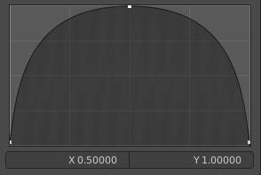
Curve window
Tweak and adjust the falloff curve by clicking at a curve point and dragging it around.
Double click adds a new point.
Holding down ctrl activates temporary snapping.
Holding down shift enables slower movement, which allows more accurate setting.

X / Y
The position of the currently selected curve point.

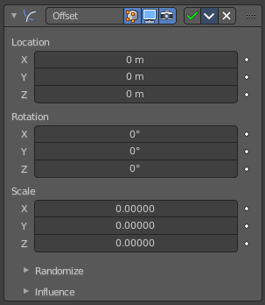
Offset
The Offset Modifier changes the strokes location, rotation or scale, starting from the object origin.

Location X, Y, Z
Sets strokes location offset from its object origin.

Rotation X, Y, Z
Sets strokes rotation.

Scale X, Y, Z
Sets strokes scale.

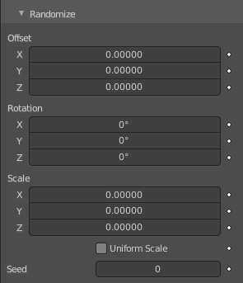
Randomize

Offset
Randomize the offset in x y and z axis.

Rotation
Randomize the rotation in x y and z angle.

Scale
Randomize the size in x y and z axis.

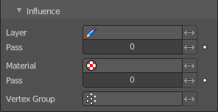
Influence

Layer
Restricts the effect only to one layer or to any layers that share the same pass index. Click to pick the layer that you want to use.

Invert
Inverts the influence.

Pass
The layer pass index.

Invert
Inverts the influence.

Material
Restricts the effect only to material that share the same material or pass index. Click to pick the material that you want to use.

Invert
Inverts the influence.

Pass
The material pass index.

Invert
Inverts the influence.

Vertex Group
Limit the influence to a vertex group.

Invert
Inverts the influence.

Smooth
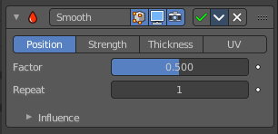
The Smooth modifier smoothens a stroke.

Mode
What elements to affect.

Position
Affects the position of the point.

Strength
Affects the color strength of the point

Thickness
Affects the thickness of the point.

UV
Affects the uv rotation factor of the point.

Factor
The smoothing amount. Higher values will increase the effect. Values outside expected range (above 1.0 or below 0.0) will distort the mesh.

Repeat
The number of smoothing iterations.

Influence

Layer
Restricts the effect only to one layer or to any layers that share the same pass index. Click to pick the layer that you want to use.

Invert
Inverts the influence.

Pass
The layer pass index.

Invert
Inverts the influence.

Material
Restricts the effect only to material that share the same material or pass index. Click to pick the material that you want to use.

Invert
Inverts the influence.

Pass
The material pass index.

Invert
Inverts the influence.

Vertex Group
Limit the influence to a vertex group.

Invert
Inverts the influence.

Custom Curve
Use a custom curve to define the noise along the strokes.

Navigation elements
The navigation elements at the top are described from left to right.

Zoom in and out
The two buttons with the magnifying glass at it zooms in and out in the curve window.

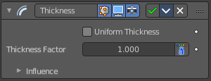
Thickness
The Thickness Modifier change the stroke points thickness.

Uniform Thickness
When enabled, makes the thickness equal for the entire strokes.

Thickness Factor
Value to add or subtract to the actual points thickness.

Weighted
Use weight to modulate effect.

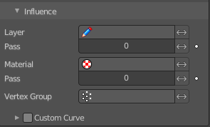
Influence

Layer
Restricts the effect only to one layer or to any layers that share the same pass index. Click to pick the layer that you want to use.

Invert
Inverts the influence.

Pass
The layer pass index.

Invert
Inverts the influence.

Material
Restricts the effect only to material that share the same material or pass index. Click to pick the material that you want to use.

Invert
Inverts the influence.

Pass
The material pass index.

Invert
Inverts the influence.

Vertex Group
Limit the influence to a vertex group.

Invert
Inverts the influence.

Custom Curve
Use a custom curve to define the noise along the strokes.

Navigation elements
The navigation elements at the top are described from left to right.

Zoom in and out
The two buttons with the magnifying glass at it zooms in and out in the curve window.

Tools
Tools is a menu where you can find some curve related tools.

Reset View
Resets the curve windows zoom.

Vector Handle
Set handle type to Vector.

Auto Handle
Set handle type to Auto.

Auto Clamped Handle
Set handle type to Auto Clamped.

Extend Horizontal
Extend the curve points horizontal before the first curve point and after the last curve point.

Extend Vertical
Extend the curve points vertical before the first curve point and after the last curve point.

Reset Curve
Resets the curve to the initial shape.

Use Clipping
Clipping options. Set up clipping for the stroke.

Delete Points
Deletes selected curve points.

Curve window
Tweak and adjust the falloff curve by clicking at a curve point and dragging it around.
Double click adds a new point.
Holding down ctrl activates temporary snapping.
Holding down shift enables slower movement, which allows more accurate setting.

X / Y
The position of the currently selected curve point.

